Notes about session3
1 /CSR vs SSR
Restaurant analogy :
Client-Side Rendering (CSR - Traditional React):
You walk into an empty restaurant. The waiter gives you a menu (empty HTML). You order (loads JavaScript). The kitchen cooks (fetches data). You wait. Finally, food arrives (page shows). This takes time!

Server-Side Rendering (SSR - Next.js):
You call ahead. Kitchen starts cooking while you're on your way. You arrive, food is on the table. You eat immediately!
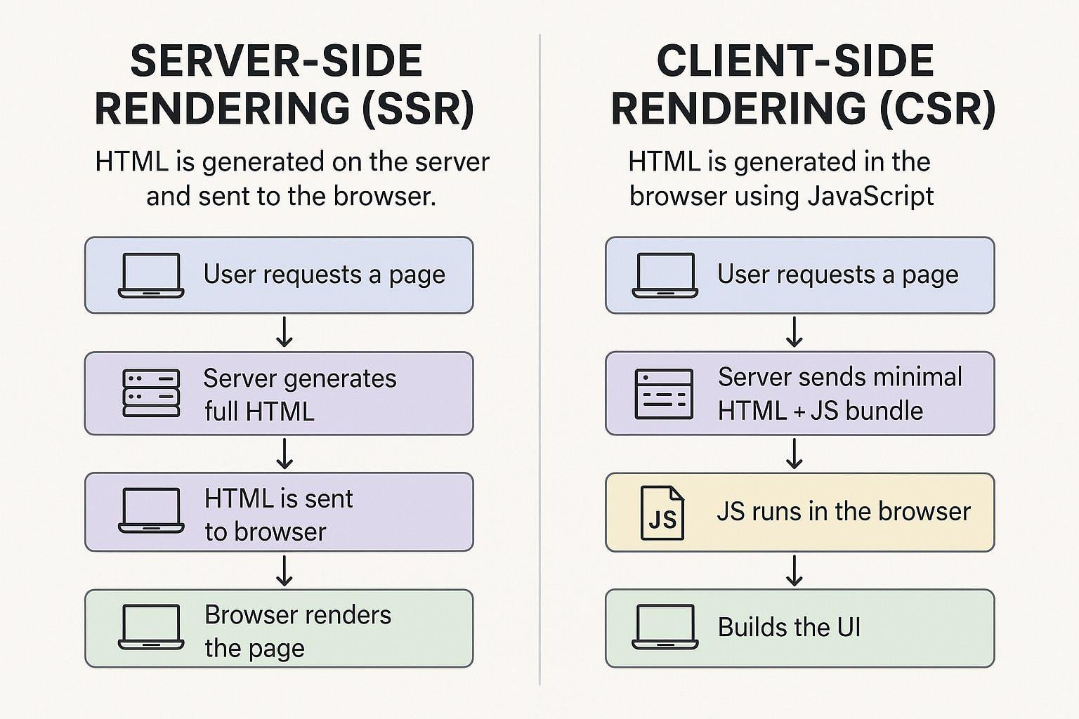

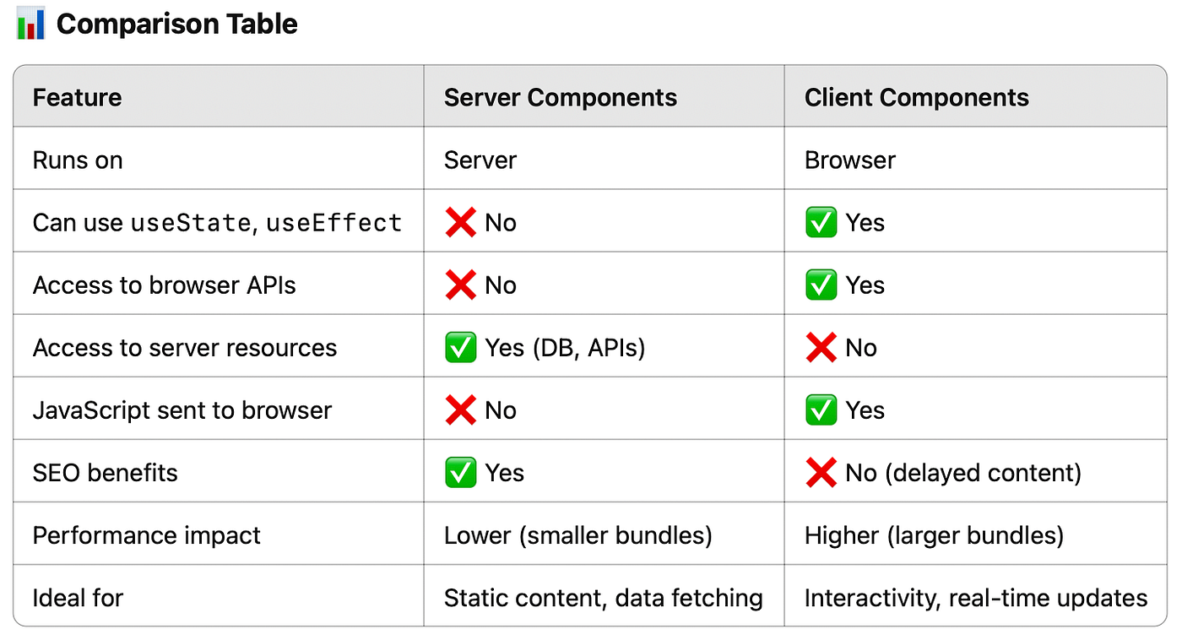

2/What are Layouts?
- Layouts = Wrapper components that apply to multiple pages
- Like a template that surrounds your page content
- Root Layout (app/layout.tsx) → Applies to ENTIRE app
- Nested Layouts → Apply to specific sections only
File structure = Route structure
app/
├── layout.tsx → Applies to EVERYTHING
├── page.tsx → Homepage (/)
├── about/
│ └── page.tsx → /about
└── shop/
├── layout.tsx → Only applies to /shop/*
└── page.tsx → /shop
Code example :
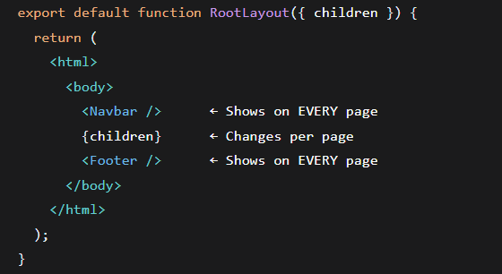

Benefits:
- ✅ No code duplication (DRY principle)
- ✅ Consistent UI across pages
- ✅ Easy to update global elements
3/React router vs next js file_based routing :
Old react : | Next.js File-Based Routing (New!):
// Need to install: npm install react-router-dom  // Need to configure routes manually  <BrowserRouter>  <Routes>  <Route path="/" element={<Home />} />  <Route path="/about" element={<About />} />  <Route path="/products" element={<Products />} />  </Routes>  </BrowserRouter> | Just create files in app/ folder:  app/page.tsx → Automatic: /  app/about/page.tsx → Automatic: /about  app/products/page.tsx → Automatic: /products
4/SHADCN/UI :
What is it?
- Collection of reusable UI components
- Built with Tailwind CSS + Radix UI
- Copy-paste components into your project
- NOT a component library (you own the code)
https://ui.shadcn.com/docs/installation
Why Use shadcn?
- Accessible - Works with screen readers
- Customizable - You own the code, can modify
- Consistent - Same design system
- Fast development - Don't build from scratch
5/TANSTACK QUERY (formerly React Query)
https://tanstack.com/query/v5/docs/framework/react/installation
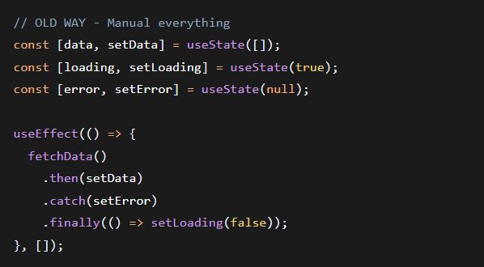
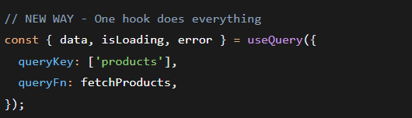
Why It's Awesome:
- Automatic Caching - No duplicate requests
- Background Updates - Fresh data automatically
- Error Retries - Tries again if fails
- Loading States - Built-in isLoading, isFetching
Key Concepts:
Query Key:
['products'] // All products
['products', 'electronics'] // Electronics only
['products', 123] // Product ID 123
- Unique identifier for your query
- Used for caching and invalidation
Query Function:
javascript
async function fetchProducts() {
const res = await fetch('/api/products');
return res.json(); // MUST return data
}
Query States:
- isLoading - First time loading (no data yet)
- isFetching - Any fetch in progress
- isError - Query failed
- error - Error details
- data - Your actual data
- refetch() - Function to reload data
TanStack Query is your smart data assistant. You tell it what to fetch, it handles everything else!"
Providers :
The Problem:
- TanStack Query needs to be available to ALL components
- Without Providers, useQuery won't work
- Error: "No QueryClient set, use QueryClientProvider"
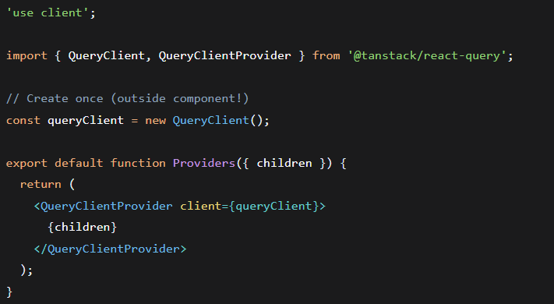
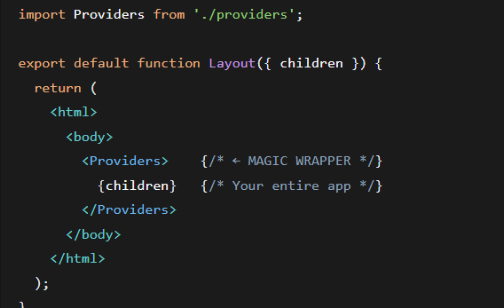
6/custom hooks :
What are Custom Hooks?
- Functions that use React hooks inside
- Reuse logic across components
- Must start with use (React convention)
Why Create Custom Hooks?
- Reusability - Use same logic in multiple places
- Organization - Keep logic separate from UI
- Testing - Test logic independently
- Clean Components - Components focus on UI only

